|  |
| --- |
| 新东方在线英语学习 |
| 新概念 1 册 |
| Lesson117-118 |



扫一扫。更多有趣的英语资讯。

# Lesson 117 单词讲解

1. dining room: 餐厅dai ning
2. coin: 硬币kao in

note, 纸币

1. mouth: 嘴巴

a big mouth

1. swallow: v. 吞下si wa lou

n. 燕子

He tried to swallow the food.

1. later: 后来
2. toilet： 洗手间、厕所tu ao lei te

# Lesson 117 课文讲解

1. We looked for them, but we could not find… look for & find寻找 &找到

look & see listen & hear

Look! Can you see it? Listen! Can you hear it?



Look for it! Can you find it?

I'm him, but I can hear nothing, because there is something wrong with my .

1. seeing, eyes
2. listening to, ears
3. finding, eyes
4. hearing, ears
5. While…our little boy, Tommy found two small coins… our little boy, Tommy

同位语：

* 1. 功能：解释名词
  2. 结构：名词+名字，名字+名词中国**, an ancient country in Asia.**

# 林书豪, a popular basketball player from Taiwan.

丰台**, a well-known district in Beijing.**

芙蓉姐姐**, a confident “s” women.** 自我介绍：ka fei en dent

Hello. I’m Venus. I’m a teacher. I’m from Shan’xi province. I live in Beijing now.

Hello. I’m Venus, an English teacher in New Oriental.

I’m from Shan’xi province, a nice place in the west of China. I live in Beijing, the capital city of China.

1. He put both into his mouth. both 代词

=he put the two coins into his mouth

We both tried to get the coins, but…

* 1. both: 代词

Both are good. both= the two books

* 1. both: 副词（动词前、情 be 后）

We both like English.

They can both sing.

1. …but I haven’t had any change yet. change:
   1. 改变
   2. 找零的钱

# Lesson 117 语法讲解

1. 过去进行时态：
   1. 功能：过去某一时刻、时段正发生的动作
   2. 结构：主语 + was\were + doing

She was doing her homework at 10:00 last night. They were having a date from 7:00- 9:00 yesterday.

* 1. 疑问形式：



was\ were 提前

She was doing her homework at 10:00 last night. Was she doing her …?

D. 否定形式：

was\were+ not

They were having a date from 7:00- 9:00 yesterday. They were not having a date …

1. 时间状语从句：
   1. 概念：句子作时间状语。

He was calling his girlfriend at 10:00.

He was calling his girlfriend when he was driving.

* 1. 引导词：

when\ while\ as\ before\ after… when: 万能引导词

while: 多接进行时态

as: “一边一边”，紧接着发生

When you think you know nothing, you begin to know something.

While everyone was working hard, I was enjoying my holiday.

We always sing as we walk.

1. Jane was waiting （wait） for me when I arrived(arrive).
2. My brother came into the living room while I was dancing (dance).
3. What was Jim writing (write) when the teacher came in?
4. When I arrived at his office, he was speaking (speak) on the phone.
5. I a meal when you me.
   1. cooked, were ringing c. was cooking, were ringing
   2. was cooking, rang d. cooked, rang
6. While she TV, she a sound outside the room.
   1. was watching, was hearing
   2. watched, was hearing
   3. watched, heard
   4. was watching, heard

# Lesson 118 单词句型讲解

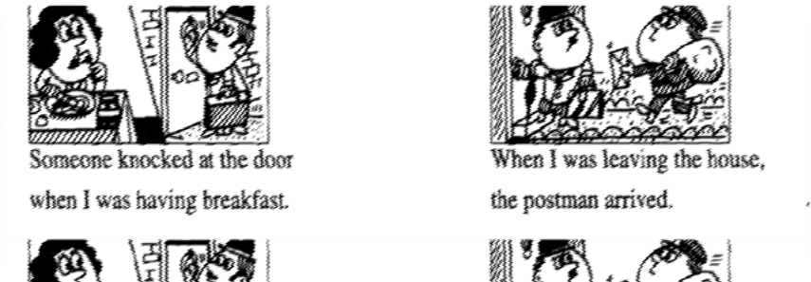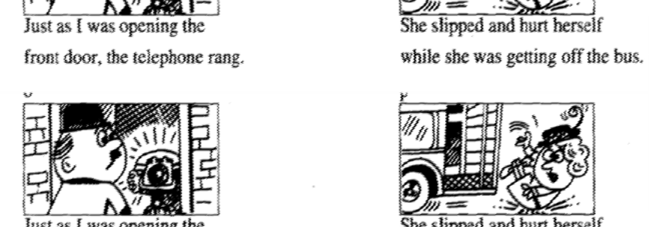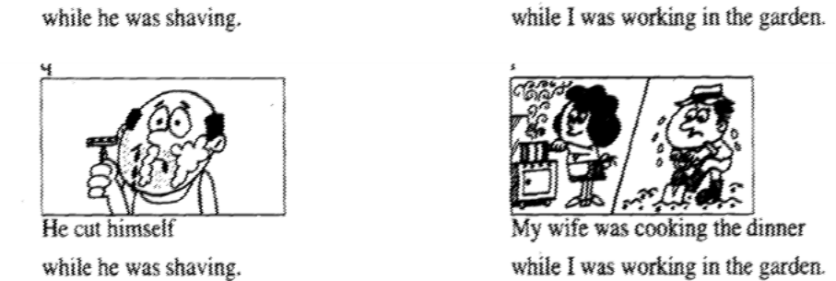

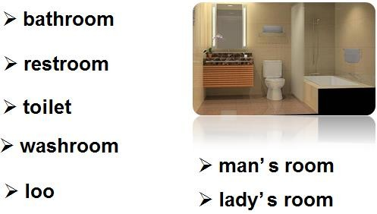**Lesson 117&118 知识拓展**

